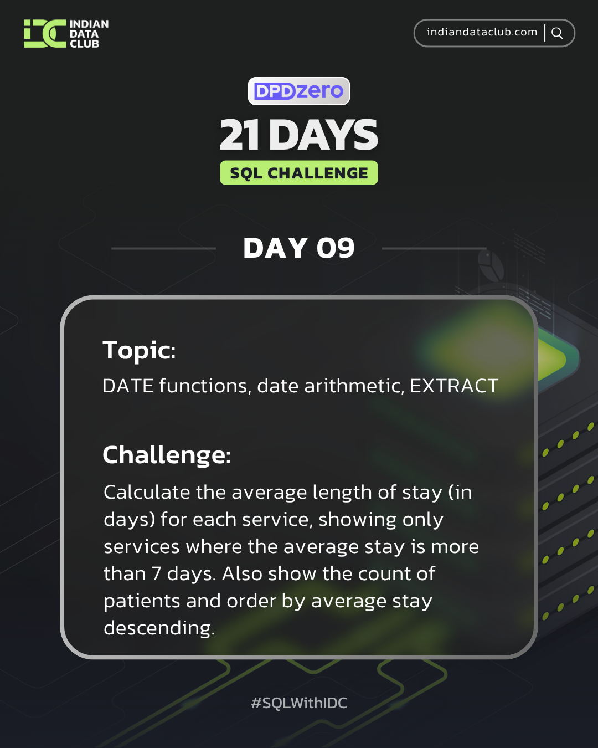

Day-9 SQL Challenge
Day-9 Challenge:
Calculate the average length of stay (in days) for each service, showing only services where the average stay is more than 7 days. Also show the count of patients and order by average stay descending.
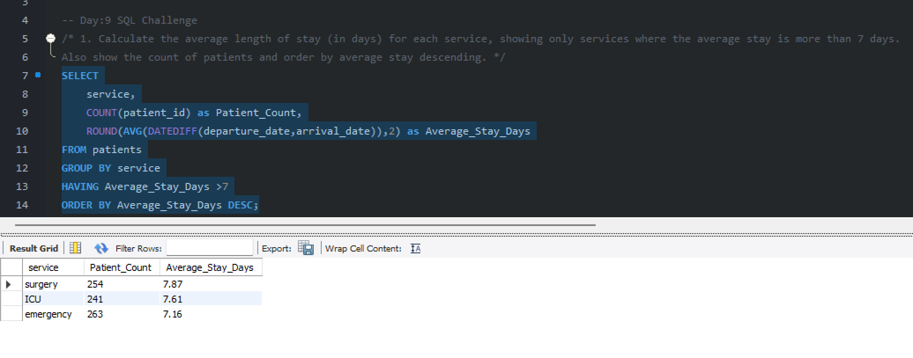
Practice Questions:
1. Extract the year from all patient arrival dates.
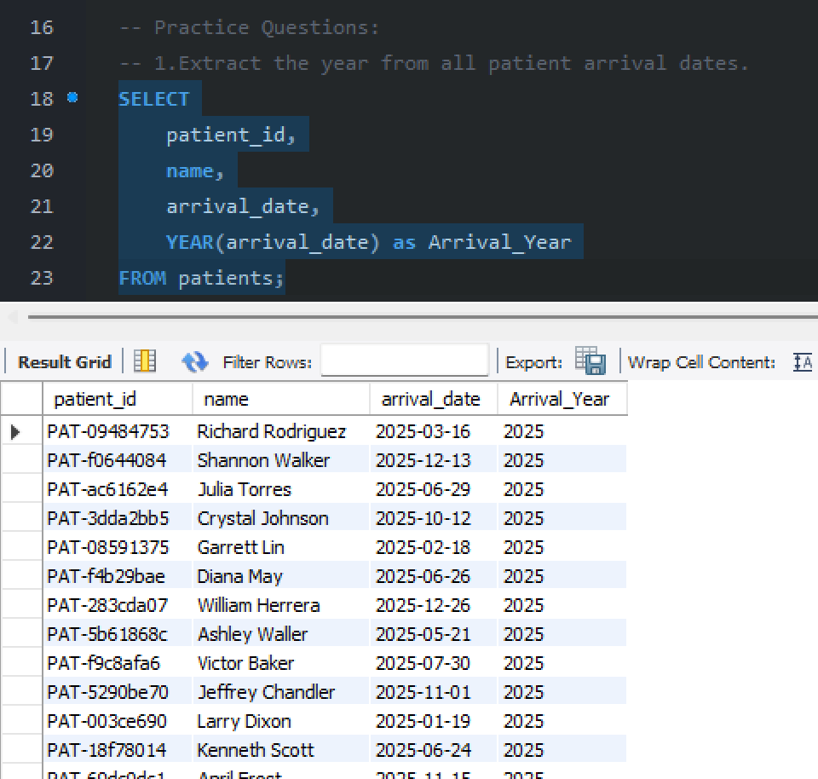
2. Calculate the length of stay for each patient (departure_date - arrival_date).
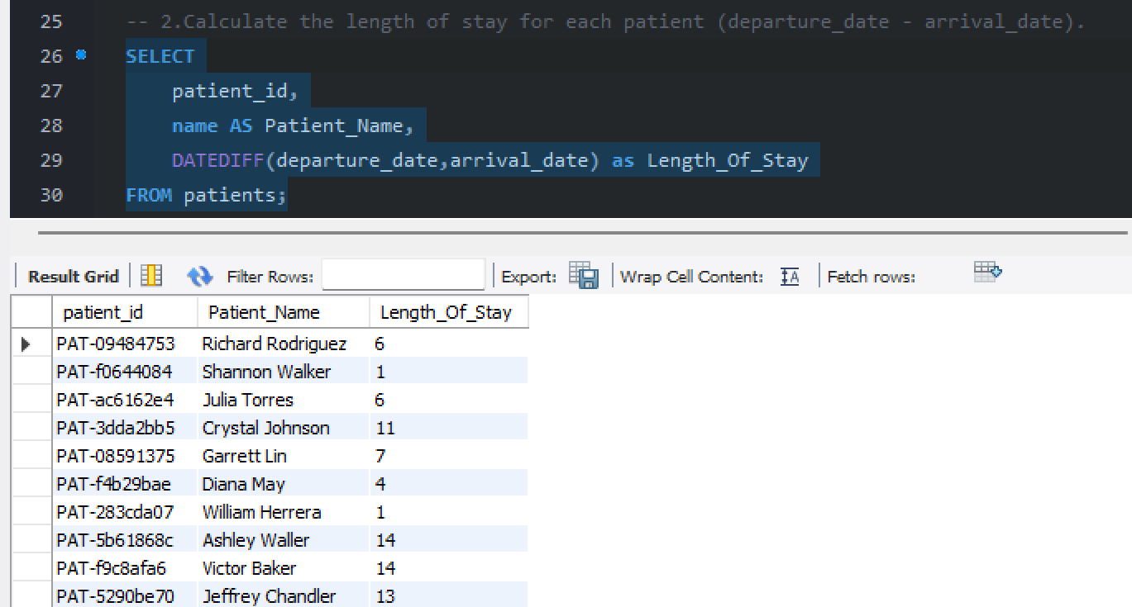

3. Find all patients who arrived in a specific month.
